Traditional IT Overview:

How Websites work:

Analogy:

- When we’re connecting to a server, we use the network to connect the client to server to access the website’s data.

- To connect to the server, client sends the request to the server.

- The server identifies the client with the help of IP addresses given to each one of them.

- Due to the IP address, the request is sent by the client to the server since the source and destination IP address is mentioned in the request/data. This is known as routing.

- Once this IP is fetched by the server, it gives the data to the client as a form of acknowledgement.

Example:

- When we want to send a letter to a close one, with the letter (Data/request), we mention the sender’s address (Source), as well as receivers address(destination).

- Due to this the, Letter is properly sent to the close one.

- This simplifies the task of the Post Office to deliver the letter.

What is a Server Composed of?

- Compute: CPU

- Memory: RAM

CPU: It is used to do the computational logical process like calculations, etc.

RAM:

- It is the random storage of the memory of the computations performed by the CPU.

- It is used to quickly show the computed data stored in it.

CPU and RAM:

- They both combinedly act as a Brain to the body of Computer.

Storage: Data

- The Storage as the long-term storage of data.

Database:

- For the data to be in a Structured manner, there is a Database for the storage.

- It helps us to run queries for extracting a specific data we need.

Networking:

- Used to understand the flow of the data packets.

- Routing Protocols.

- Routers, Switch, DNS servers.

IT Terminologies:

- Network: It is a connection of cables, routers, switches for network communication.

- Routers: Used as a Wide Area network technology for routing via Ip addresses between Client and Server.

They can connect with other IP address for transferring of the data.

- Switches: Used as the Local Area Network technology for passing the data packets from the router to the specific client.

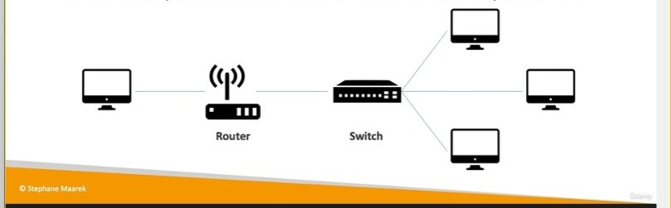

Traditional background before Cloud Computing:

- When people used to start companies at their home, they used to do that in their home or garage.

- So, they have to buy server and put it in garage.

- According to many documentation videos, Google, Amazon, all started in Garage.

- As the demand grew, they needed to put more and more servers into their garage. Due to this the garage as well as homes started to be filled with server and hardware components.

- This was good for the company but was equally bad for the accommodation purpose.

- When the company grows big, it will soon turn in the office, and there would be a special room allocated as Data Center.

- The Data Center is the place where all the hardware and networking components were to be kept. The company could add more and more servers into the Data centers.

Problems with the Traditional Approach:

- Pay the rent for establishing a space for Data Center.

- Pay Maintenance, Cooling, Power supply.

- Pay for the Human Resource to be present all day to look after the hardware components.

- Pay the Networking engineer who established all the connections, adding or replacing servers.

- Spend more time with the hardware and networking than the business.

- Scaling is limited for managing a lot of traffic in a sudden manner.

- Cannot withstand natural calamities like fire, earthquake, etc.